Spicy Mexican Corn Dip

Servings 6

Ingredients
1 can green chilies diced, 4 oz
1 can fiesta corn drained
1 cup mexican cheese shredded
3/4 cup cottage cheese
3/4 cup greek yogurt plain

Instructions
- Lightly grease one pie plate or baking dish.
- Mix together all ingredients and add to your dish.
- Bake at 350 degrees for 20 minutes.
- Brown the top of the dip for 2 minutes on the broil setting. Watch the oven, though–it goes from brown to burned quickly!
- Serve with tortilla chips or veggies.

Garlic Bread
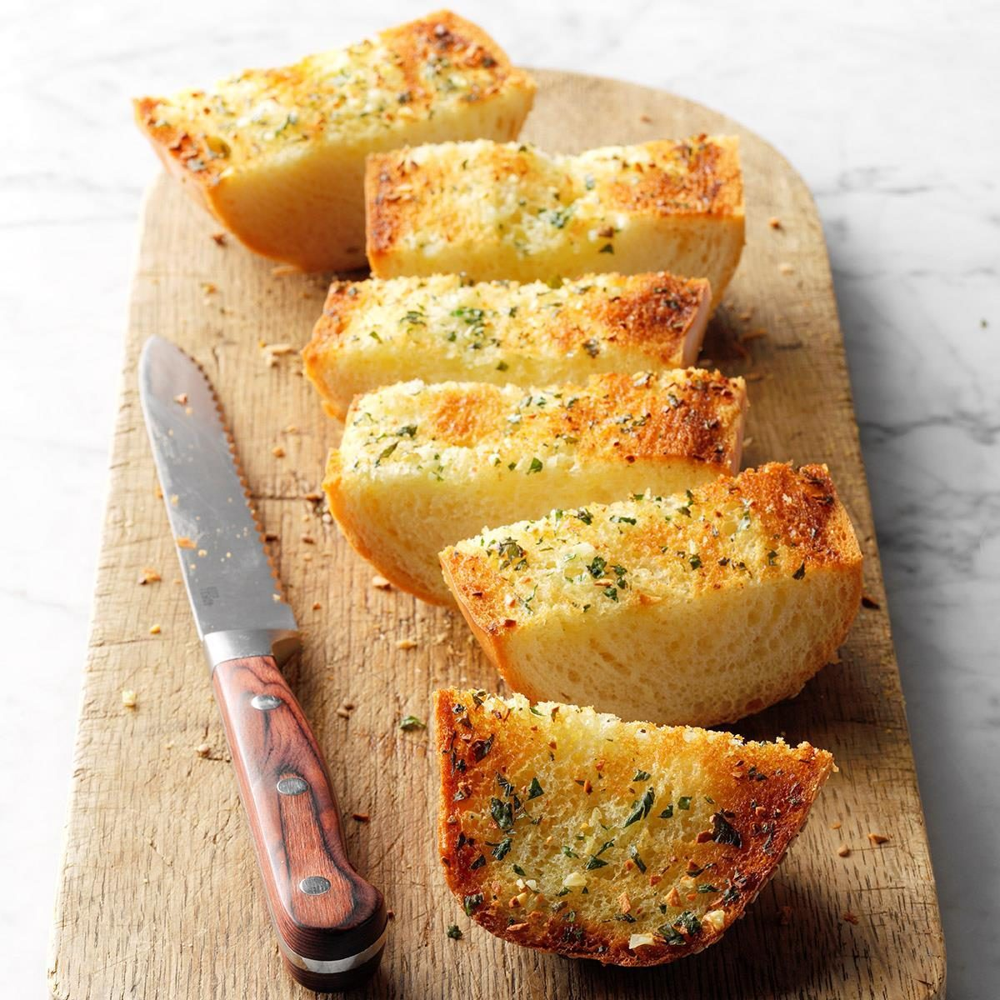

Ingredient

1/2 cup butter, melted

3 to 4 garlic cloves, minced
1 loaf (1 pound) French bread, halved lengthwise
2 tablespoons minced fresh parsley

- Directions
- 1. In a small bowl, combine butter and garlic. Brush over cut sides of bread; sprinkle with parsley. Place, cut side up, on a baking sheet.
- 2. Bake at 350° for 8 minutes.

Lasagna Roll Ups

Servings: 12
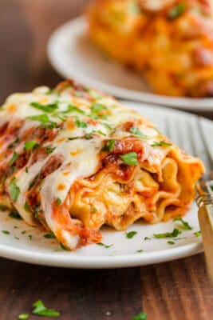
Ingredients
12 lasagna noodles cooked to package instructions
16 oz ground beef 85% lean
24 oz marinara sauce
1/2 cup diced onion
3 garlic cloves minced
1 tsp sea salt or to taste for red sauce
1/2 tsp black pepper or to taste
1/2 tsp dried oregano
15 oz ricotta cheese
1 large egg
1/4 cup parmesan cheese shredded
3 cups mozzarella cheese shredded, divided
1/4 cup parsley chopped, plus more to garnish

Instructions
- Preheat oven to 375f.
- Cook noodles in a large pot of salted water according to package instructions then drain and fill pot with cold water to stop the cooking process and keep noodles from sticking together.In a deep pan or dutch oven, over medium-high heat, cook ground beef until no longer pink, breaking up with a spatula.
- Add onion and cook until softened.
- Add garlic, 1 tsp salt, 1/2 tsp pepper and 1/2 tsp oregano and saute another minute. Add marinara, bring to a simmer and turn off the heat.
- Spread 1/2 cup meat sauce over the bottom of a casserole dish. In a large bowl.
- Stir together ricotta, 1 egg, 1/4 cup parmesan cheese, 1 1/2 cups mozzarella cheese and 1/4 cup parsley.
- Spread 1/4 cup of cheese mixture over the top of each noodle.
- Add a heaping Tbsp of meat sauce in a strip down the center of the noodle. Roll noodles up and arrange in the prepared casserole dish.
- Spread remaining meat sauce over the tops of roll-ups and sprinkle on the remaining 1 1/2 cups mozzarella cheese.
- Cover with foil, making sure foil isn't touching cheese
- Bake covered at 375 f for 30 minutes. Uncovered for 10 minutes.
- Garnish with parsley to serve.

